Angie Ramirez

Fall CS361

Homework on SML and PROLOG

**Homework on SML and PROLOG**

**SML**

1. What are the types of the following expressions?

* [(1,5), (2,3), (5,6)];

val it = [(1,5),(2,3),(5,6)] : (int * int) list

* fun f(x:real) = true;

val f = fn : real -> bool

* map f;

val it = fn : real list -> bool list

1. Provide expressions of the following types:

* int * bool

(5, false);

* int list * bool

([1,2,2],true);

* int * real -> bool list

fun f(x:int, y:real) = ([true, false]);

1. Write the following SML functions:



fun rec(n) = if n=0 then 1 else 2 * rec(n-1);

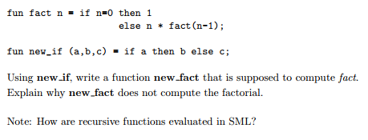

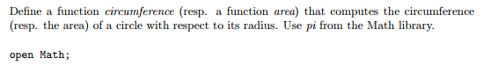

fun circumference(r) = 2.0 * pi * r;

fun area (r) = pi * r *r;

How to use map to add 3 to each elements of a list  
  
val list = [1,2,3,4];  
fun add(e) = 3+e;  
map add list;

1. Implement the datatype BinaryTree and all the functions that are provided in the lecture notes: lookup, inorder, preorder, postorde, left_subtree, right_subtree and label. Provide screenshots to show that your code is correct. Provide 2 tests for each function.

**PROLOG**

1. Let us consider the following set of facts that describe the mother predicate.

mother(linda, paul).

mother(cathy, andrew).

mother(cathy, laura)

* Define a predicate female(X) which holds iff X is a female
* Define a predicate sister(X,Y) which holds iff X and Y are sisters
* Implement female and sister in PROLOG
* Provide screenshots

female(linda).

female(cathy).

female(laura).

sister(X,Y) :- female(X), mother(M,X), mother(M,Y).

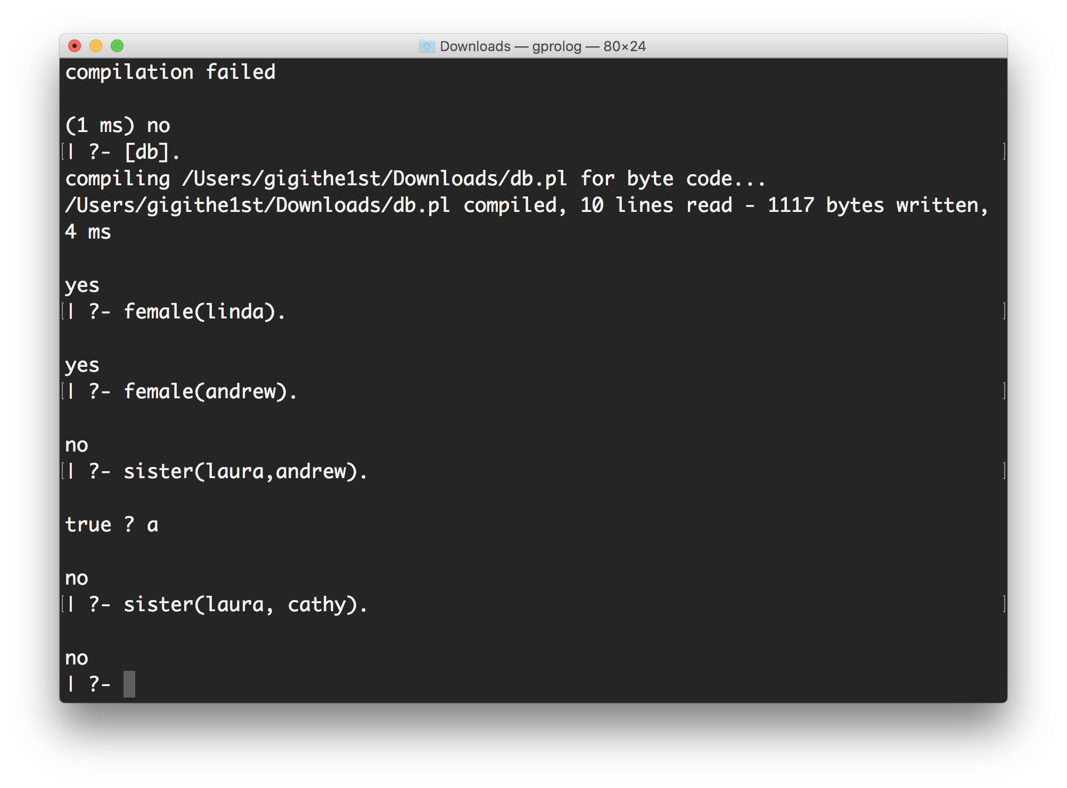

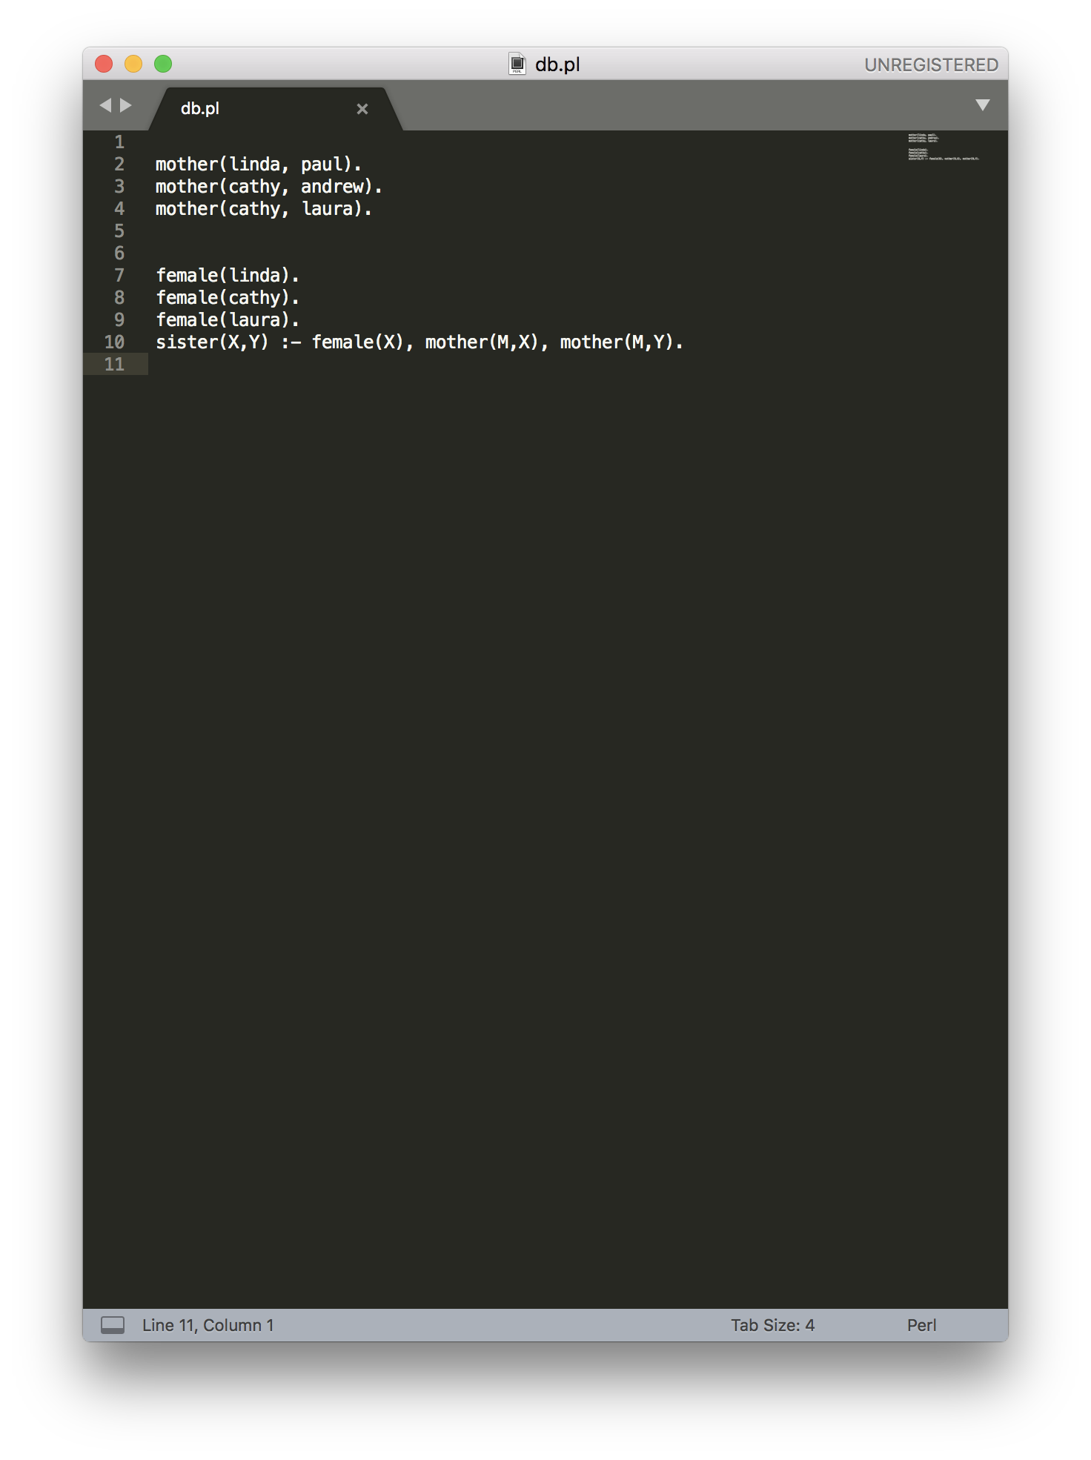

1. Implement the function g such that g(x) = x+5.

g(X,Y) :- Y is X+5.